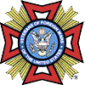
VFW Post 6605
General Membership Meeting
January 20th, 2019

Opening Ceremony: Commander Wally Hinton opened the meeting at 1800 hours. Chaplin Gary Tisdale gave the opening prayer and Commander Wally Hinton led the General Membership in the pledge of allegiance to the U.S. Flag. Voice of Democracy Winner presented a check for $100.
Roll Call of Officers/Quorum: The required quorum of members was present to conduct the meeting.
Membership: The names 5 new qualifying members were read and a motion to accept new members was made by Mitch Odom, seconded by John Garrett. Motion Passed.
Previous Meeting Minutes: Minutes for General Membership Meeting Nov. 2019 were read by Adjutant Bill Lister. No meeting in December. A Motion to accept Minutes was made by John Garrett; seconded by Rollie Hickman. Motion Passed.
Quartermaster’s Report: Quartermaster Ty Matthews gave report for Nov and end of Oct. Motion to accept Quartermasters report was made by Mitch Odum; seconded by John Garrett. Motion Passed.
Communications: Report of two members lowering the flag in honor of those lives lost at Pearl Harbor Dec. 7th 1941.
Service Officer: Service Officer Mitch Odom provided assistance to one individual.
House Committee: Report was given and handed in by Chairman Donna Gray.
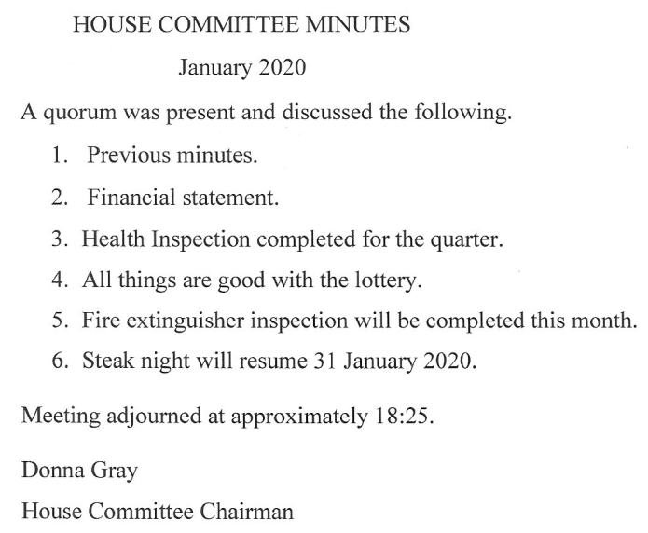
Hospital Report: No new information
.
Chaplain’s Report: Chaplin Gary Tisdale gave the report. Added General Order #7, National Tracking identified 3 members who have been taken off the National Rolls.

National Home Ceremony: Chaplin Gary Tisdale conducted the National Home ceremony; A donation of $65 was collected.

Unfinished Business: None

New Business:
- John Garrett asks that everyone be vigilant of fellow comrades who might have issues; to take the time to listen and help them when they reach out in distress.
- Motion was made by Ty Matthews to give whatever help is needed to the Mustang Car club car show May 2nd. Seconded by Mitch Odum, Motion passed.
- Mitch Odum made a proposed to have a fire pit constructed near the back of the building on the Corder Road side. Bill Lister made the motion to approve fire pit project, John Garrett Seconded, motion passed.
- Discussion was had concerning deteriorating grill for steak night. Ty Matthews made a motion to set back $200 from each steak night to fund a new grill project, seconded by John Garrett; Motion Passed.
- Ty Matthews presented a proposal to renovate the post hall. Ty is going to get estimates to upgrade and make the hall more presentable for a more profitable venue.
- New gun raffle will come in the near future once a gun has been purchased.

Good of the Order:
General Order #6 & #7 for the Month of December 2019 and January 2020 will be posted on bulletin board in hallway.

General Order #6 - Pertains to Harassment and Discrimination, VFW viewpoint concerning such matters and the consequences of such actions. Also addresses membership dues.
General Order #7 - Pertains to National meeting, State and District meeting dates, and reiterates Life Membership issues and benefits.

Bill Lister asks that if anyone has had any email changes or address changes please provide us with the new information.

Closing Ceremony: Chaplain Gary Tisdale gave the closing prayer. There being no further business, Commander Wally Hinton led the General Membership in the closing salute to the Flag. Commander Hinton declared the meeting closed at 1905 hours and announced the next General Membership meeting will be conducted 17 Feb 2020 at 1800 hours.
Respectfully Submitted, Bill Lister, Adjutant
Approved, Wally Hinton, Commander

